Requirements and Design Document

CR Name: | CR Vegam and QCLAD Integration
Client Name: | Henkel
Plant Name: | Dragon

Document Change History
Version No. | Date | Change Description | Author | Reviewed By | Approved By
V0.1 | 22-07-2025 | CR Vegam and QCLAD Integration | Dhanraj

Contents

1. Business Opportunity 3
2. Definitions, Acronyms and Abbreviations 3
3. References 3
4. CR Scope & Solution 4
4.1. CR Vegam and QCLAD Integration 4
4.1.1. Customer Requirement & Expected Enhancement 4
4.1.2. Proposed Solution: - 5
5. Additional Information 19
a. Technical Assumptions and Dependencies 19
b. Technical Risks and Issues 19

Business Opportunity
The Smart Factory Solutions (SFS) platform comprising of Vegam 4i, vLabel and associated components is an industry 4.0 solution deployed for the customer. The SFS platform enables operations to be digitized and brings efficiency for the plant. Custom changes to the system are constantly identified by users at the customer’s end / Vegam to match the needs of the plant operations. The Changes mentioned in the subsequent sections of this document are also identified for such needs/ requirements.

Definitions, Acronyms and Abbreviations
Sl. No. | Acronym | Expansion
1 | CR | Change Request (Enhancement)
2 | UAT | User Acceptance Test
3 | AUT | Application Under Test
4 | Info | Information

References
All modules’ enhancements/queries document shared by Client

CR Scope & Solution

CR Vegam and QCLAD Integration

Customer Requirement & Expected Enhancement
Henkel has requested the integration of QCLAD with MES (Vegam SFS) system to streamline the quality control processes currently followed at the Dragon plant. At present, quality-related activities such as GR testing for JIT materials and IPQC (In-Process Quality Control) are being carried out by the QCLAD team.
In the current setup, after recording the quality results in QCLAD, the operator must separately log into the MES (SFS system) to manually update the quality outcome. This additional step introduces dependencies, increases the chance of data discrepancies, and creates delays in process execution especially in scenarios where SFS needs quality results to either complete the current process order or to proceed to the next manufacturing phase.
To resolve this and ensure seamless continuity in production, the Henkel team has requested an integration between SFS and QCLAD. This integration is expected to enable the following:
- Label Printing & Handover:
  - MES (SFS) will generate and print labels containing relevant quality identifiers (such as JIT sample numbers or IPQC identifiers).
  - These labels will be physically handed over to QCLAD operators for recording quality results.
- Result Submission from QCLAD to MES:
  - After performing quality checks, QCLAD will push the quality results back to the MES (SFS) via APIs.
  - Based on the received data, the MES will continue the production process either marking the process order as complete or allowing the next phase to begin.
System Requirements and Changes for Integration with QCLAD
To enable a seamless integration between the Vegam MES and QCLAD system, the following requirements and changes need to be implemented by Vegam:
- Plant-Level Integration Opt-In
Each plant must have the ability to opt for integration with QCLAD (or any third-party system) for managing quality processes. This setting should be configurable at the plant level.

- JIT Sample – Receiving
QCLAD will send the quality results for JIT samples to Vegam via an API endpoint provided by Vegam.
- IPQC Sample – Sending
For IPQC sample testing, Vegam will generate and print labels to be handed over to the QCLAD.
The label must include the following key information:
  - Production Line
  - Is DCS Enabled (Yes/No)
  - Activity Number

- IPQC Sample – Receiving
QCLAD will push the IPQC quality check results to Vegam via an API provided by Vegam.

- Bulk to FG (Finished Goods) Relationship
Vegam will push the mapping details between Bulk and FG materials to QCLAD using a defined JSON payload structure.
  - The API should ensure the transfer of accurate and timely relationship data required for QCLAD to perform proper quality validation and tracking.

Proposed Solution: -
Enhancements will be made in the SFS system to incorporate seamless integration with QCLAD for managing quality processes across different plants. The following proposed solutions correspond to each of the requirements

- Plant Level Configuration
To implement the Vegam–QCLAD integration, a plant-level configuration setting will be introduced and managed by Vegam. This configuration will determine the quality process flow for each plant.
Setting Name: Quality Process Handling Mode
Configuration Type: Radio Button (Single Selection)
Options:
- SFS Quality Flow
→ The plant will follow the regular SFS-managed quality process for JIT and IPQC.
- Third-Party Quality Flow (QCLAD)
→ The quality processes (JIT and IPQC) will be integrated with QCLAD. Vegam will receive data as per the agreed API flows with QCLAD.
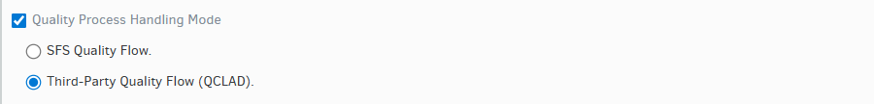

Behaviour:
Once a plant is configured with this setting:
All quality transactions (JIT Receiving, IPQC Receiving) will follow the respective path (SFS or QCLAD).

Note:
- The selected Quality Process Handling Mode will impact all Goods Receipt (GR) samples, including both JIT and Raw Material sample labeling.
- If the Quality Mode is set to Third-Party Quality Flow (QCLAD) for the plant,
MES will not post the Usage Decision of JIT samples to SAP, as the quality process is externally managed by QCLAD.

- JIT Sample – Receiving – Once the JIT sample labels are printed in SFS, they will be physically handed over to the QCLAD team to conduct the quality checks. Upon completion of testing, QCLAD will send the quality results back to SFS through the API endpoint provided by Vegam, using the agreed JSON payload structure.

Note: All the API details have been incorporated into a separate document.

Case 1 – Approval Scenario
- Label Generation in MES:
  - When a JIT sample is generated in MES, a physical label is printed and handed over to the QCLAD team.
  - Simultaneously, MES logs the sample in the Quality Module with status Pending and flags the sample as Awaiting test results from QCLAD.

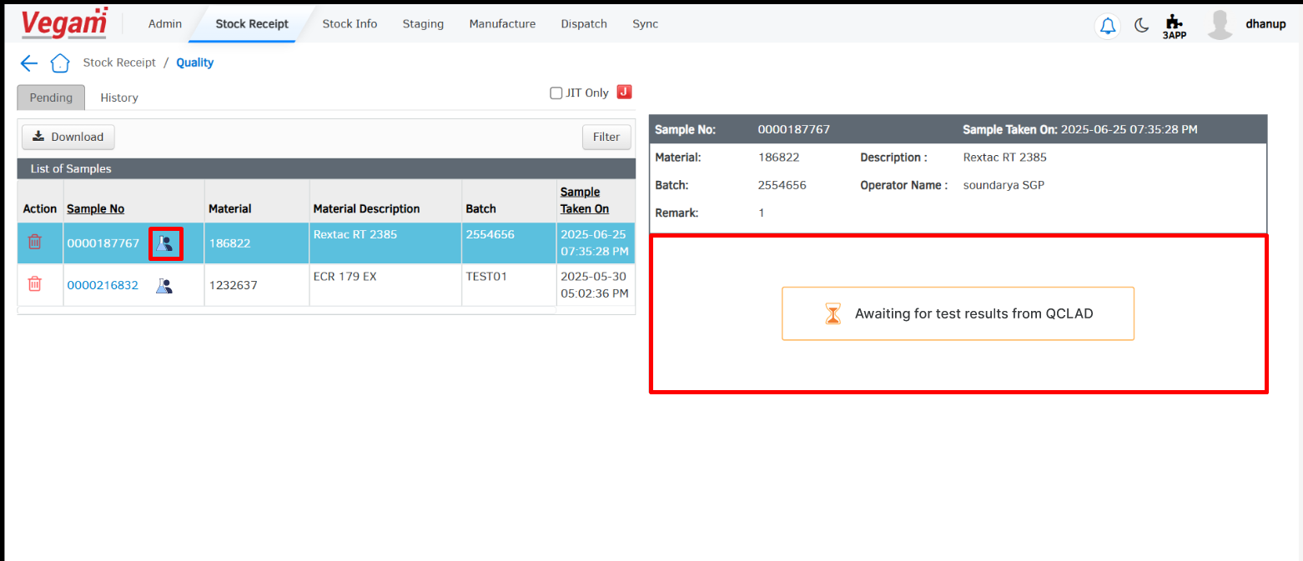

- Testing in QCLAD:
  - QCLAD performs the required testing on the received sample.
  - Upon successful completion and approval of the sample, QCLAD pushes the results to MES via the designated Vegam API.
  - The payload is sent in the agreed JSON structure.

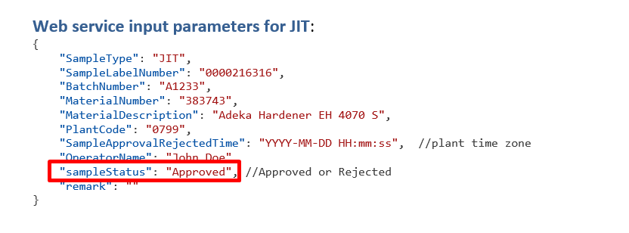

- MES Updates:
  - Upon receiving the “Approve” result from QCLAD:
    - The sample record in MES is updated from “Testing In Progress” to Pass.
    - The test result is moved to the History tab.

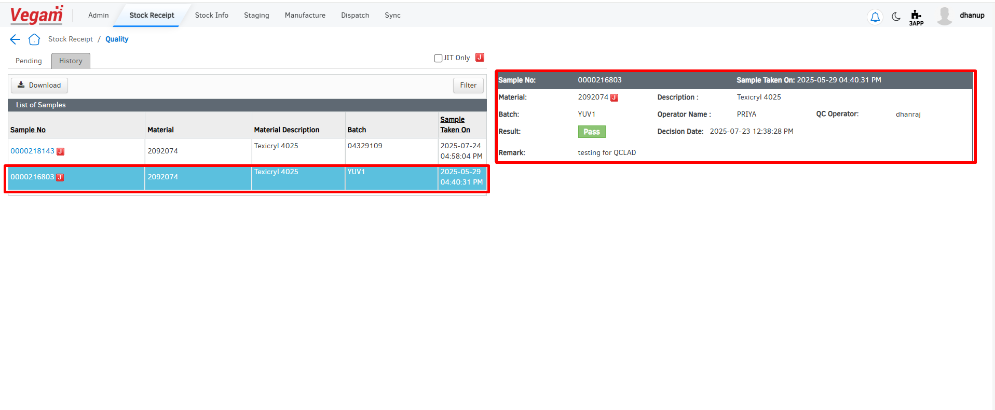

Case 2 – JIT Reject

Workflow:
- Sample Label Printed in MES:
  - MES prints the sample label once the sampling condition is triggered.
  - The label is handed over physically to the QCLAD team.
- Status Set as ‘Pending / Testing In Progress’:
  - As soon as the label is printed, MES updates the sample status as “Pending”.
  - Internally, MES marks that QCLAD is performing testing.


- QCLAD Performs Testing:
  - QCLAD conducts the physical quality checks.
  - After testing, QCLAD sends the result back via the API provided by Vegam.
- API Call with Rejection:
  - QCLAD sends a Reject result with payload:
  - The API receives and validates the sample number.
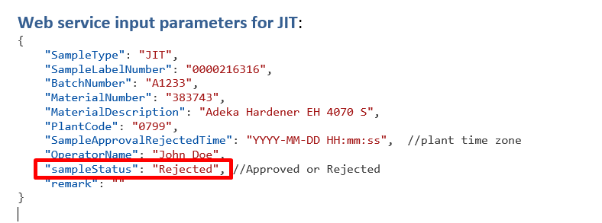

- MES Updates Result:
  - MES marks the sample as “Rejected” in the quality module.
  - Status is updated in the history tab with timestamp and result.
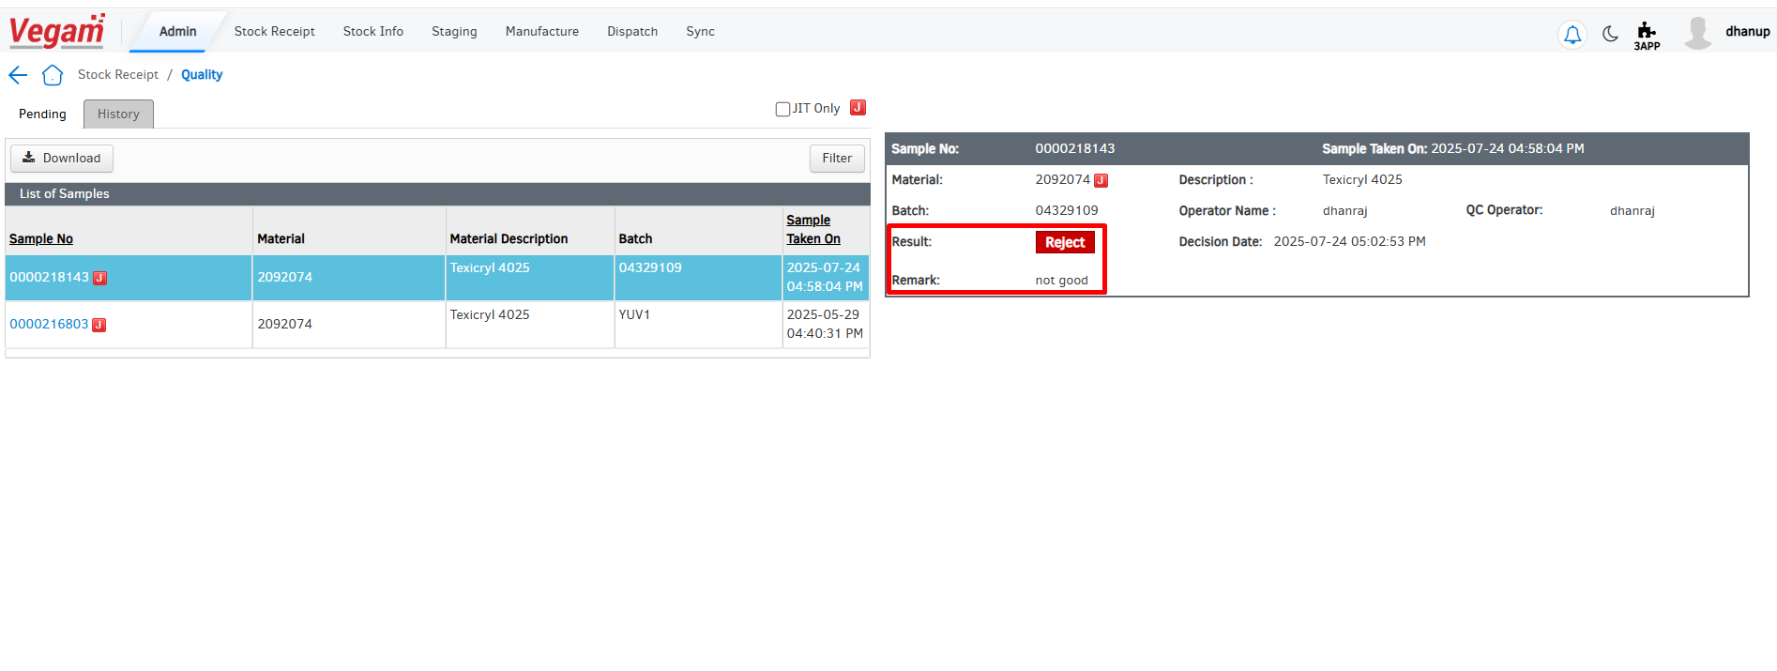

Lifecycle.
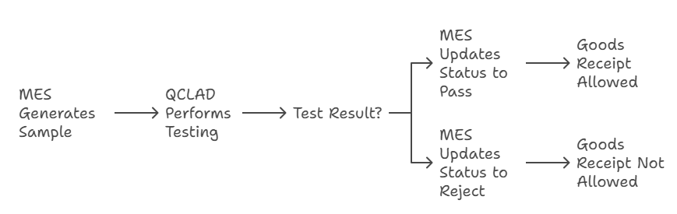

- IPQC Sample – Sending
🔧 Enhancement – IPQC Label Update for QCLAD Integration
To support integration with QCLAD and ensure proper traceability, the IPQC sample label in MES will be enhanced to include three additional data points. These details are required by QCLAD for conducting quality checks and sending results back accurately.
🆕 New Fields to be Printed on the IPQC Label:
- Production Line
  - Identifies the line on which the sample was generated.
- Is DCS Enabled
  - A flag indicating whether DCS is active or not.
  - Value will be Yes or No.
- Activity Number
  - Represents the current operational activity in SAP.
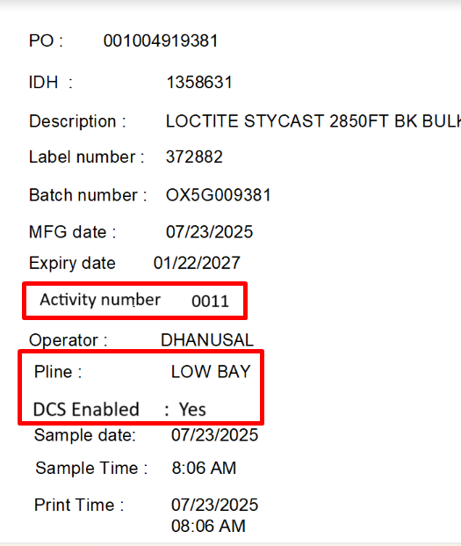

🔄 Flow of Information:
- When MES generates an IPQC sample, it will:
  - Fetch and attach these three parameters (PLine, DCS status, Activity number).
  - Print them on the IPQC sample label.
- The label will be handed over to QCLAD for testing.
- After testing, QCLAD will send results via API and include the same three values as part of the JSON payload.

- IPQC Sample – Receiving
When a plant is configured to follow the QCLAD-based quality process, all quality testing and decision-making for IPQC samples will be exclusively handled by QCLAD. In such a setup:

- MES operators will not have permission to:
  - Manually enter or edit test results.
  - Take the sample decisions.

Instead, MES will display results received via API from QCLAD in a read-only format.
✅ Case 1: Approval Flow for IPQC Sample
🏷️ Step 1: Sample Generation
- When an IPQC sample is triggered in MES:
  - A physical sample label is printed.
  - The label includes:
    - Production Line
    - Is DCS Enabled
    - Activity Number
  - The label is handed over to the QCLAD team for testing.


🔄 Step 2: MES Status Update
- MES automatically logs the sample in the Quality Module with:
  - Status: Pending
  - Flag: Testing In Progress
- MES visually indicates that testing is being conducted externally by QCLAD.

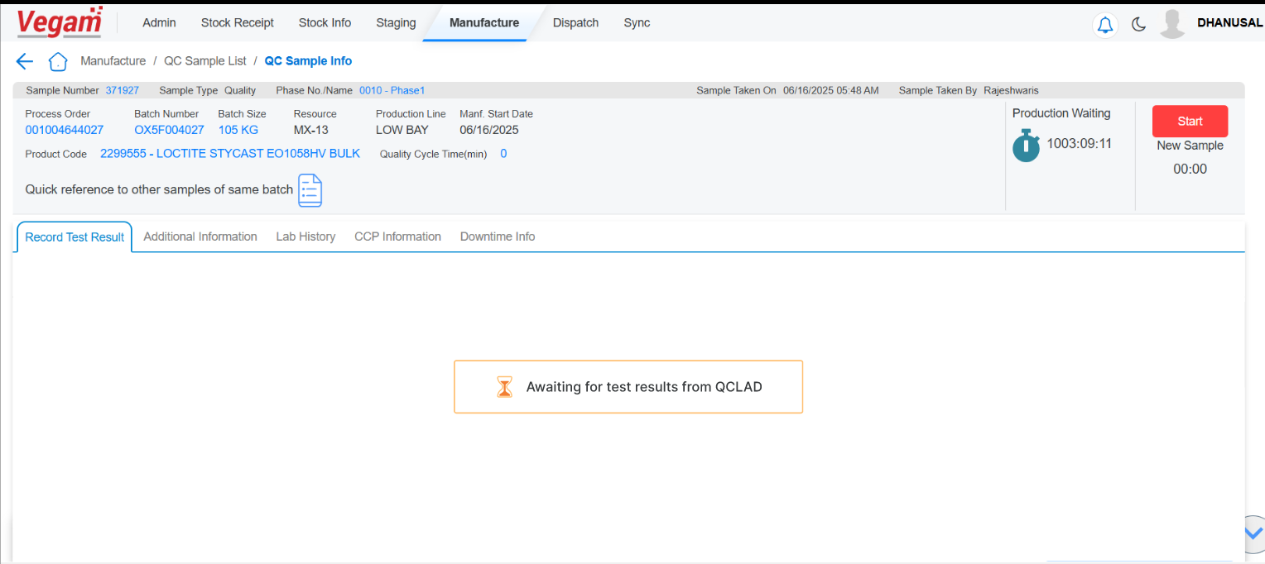

Note – SOP Test methods if maintained also system wont display if the plant is configured for the QCLAD quality flow

🧪 Step 3: Testing at QCLAD
- QCLAD:
  - Conducts quality testing based on their procedures.
  - Sends the test result via the Vegam-provided API using the agreed JSON structure.
- For an Approved sample, QCLAD sends:

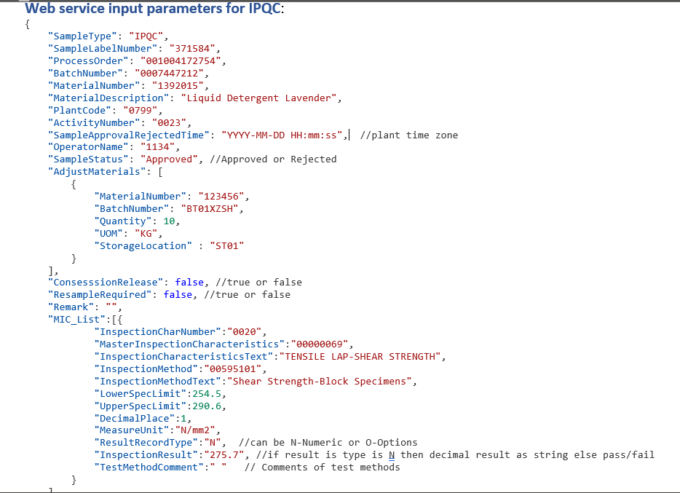

📲 Step 4: MES Updates
Upon receiving the approval from QCLAD:
- MES updates the IPQC sample record:
  - Status: Pass
  - Display: Result appears in the Quality Module
- System automatically:
  - Proceeds to the next phase of the process order.
  - If it’s the last activity, the PO status is set to: Manufacture Completed.

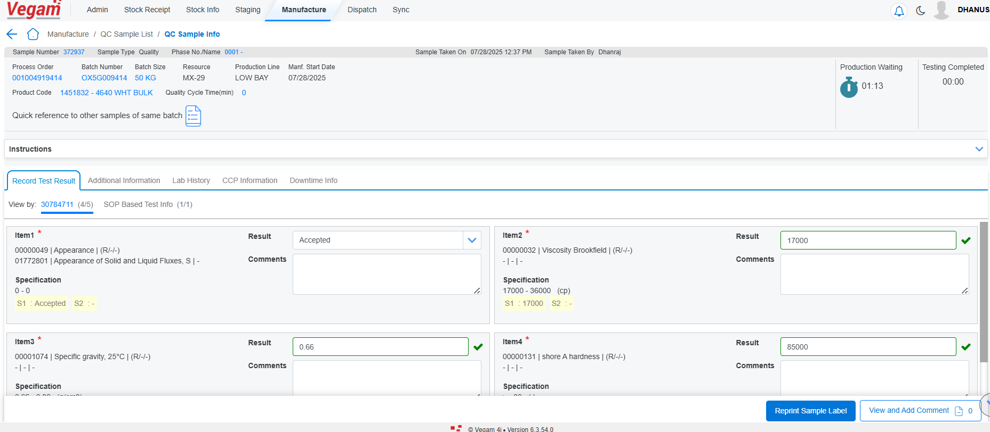

Case 2: Reject with Adjustment Material (Adjustment is done by QCLAD, not MES)
When a sample is rejected, but the adjustment is already handled by QCLAD, MES does not need to take any action to correct the material. QCLAD performs the necessary correction and just informs MES what was done for traceability.
QCLAD Testing Outcome
- Sample is rejected
- QCLAD adjusts the batch (e.g., adds ingredients or corrects defect)
- Sends result to MES:
MES Action (when isQCAdjustment =true)
- ✅ Logs the result
MES records and marks the sample as testing completed in the history tab.
- 🔁 Triggers Issue Addition
MES will automatically issue the adjustment materials provided in the adjustMaterials list (received from QCLAD via API) to the current phase of the process order.
- 👤 No Operator Involvement
MES does not require any manual input or confirmation from operators for the adjustment action.

🔧 Example
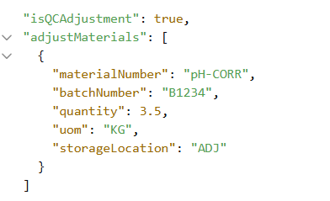

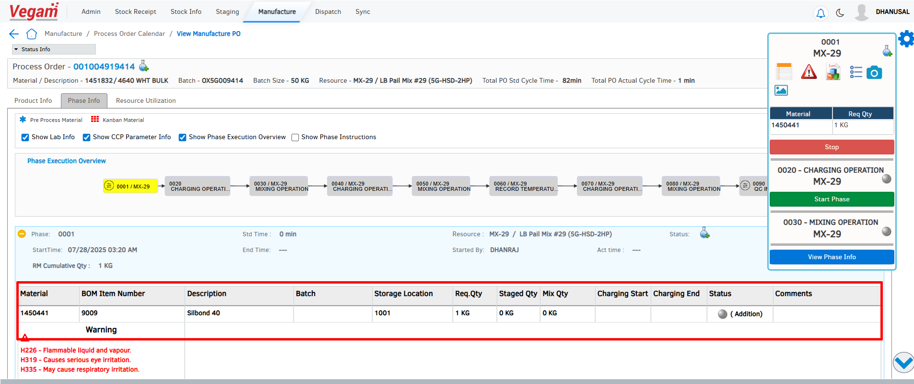

Note – The detail API details are mentioned the Integration details document

Case 3: Reject with Adjustment Material (Adjustment Not Done by QCLAD)
(When isQCAdjustment =true)
📤 QCLAD Testing Outcome
- The sample is rejected.
- QCLAD does not perform the adjustment.
- In the API payload:
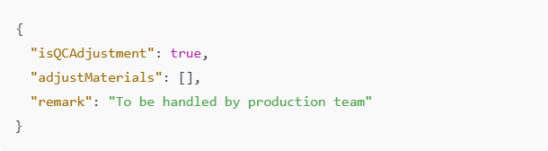
🛠️ MES Action
1. ✅ Logs the Rejection
- MES records the status in the Quality Module.
2. ⚠️ Displays Manual Action Options
- Since QCLAD didn’t handle the adjustment, MES will prompt the operator for manual intervention.
- Action button will be displayed in the MES Quality Module for the IPQC sample:
🔘 Adjust Phase – Allows the operator to issue the necessary adjustment materials and log the correction, enabling them to proceed with the next phase of production.

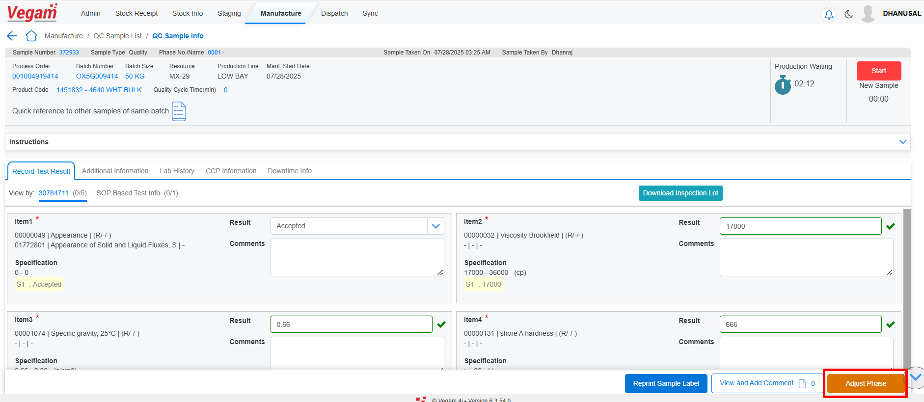

3. 📝 Remark Guidance
- The remark sent by QCLAD will be shown in MES, guiding the production team on what needs to be adjusted (e.g., “Add acid to correct pH level”).

📌 Example Flow
- Sample Rejected → QCLAD does not perform correction
- MES UI Action:
  - Shows sample as Testing in progress
  - Shows remark from QCLAD
  - Displays "Adjust Phase" buttons to the operator
- Production Operator:
  - Uses MES to issue required material and can adjusts the phase manually
  - Continues the production cycle

✅ Case 4: Reject with Concession Release
📤 QCLAD Testing Outcome
- The sample is rejected based on test results.
- However, QCLAD allows it to proceed by giving a concession release.
- In the API payload, the following key flags are sent:

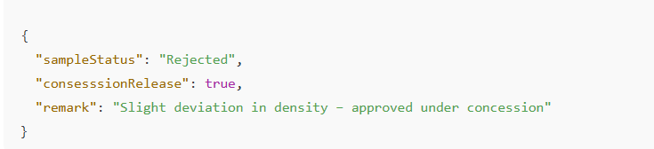

🛠️ MES Action
1. ✅ Logs Result as "Pass with Concession"
- Even though the result is Rejected, since consesssionRelease = true, MES will:
  - Flag the sample as Passed with Concession.
  - Display a special status or visual cue to indicate it's under concession release.

Note – Production line setting Enable Concession release should be enabled in SFS

2. 📝 Displays Remark
- MES will show the remark received from QCLAD in the Quality Module, so operators are aware of the reason for concession.
  - Example: “Minor deviation in pH allowed – proceed under QCLAD approval”

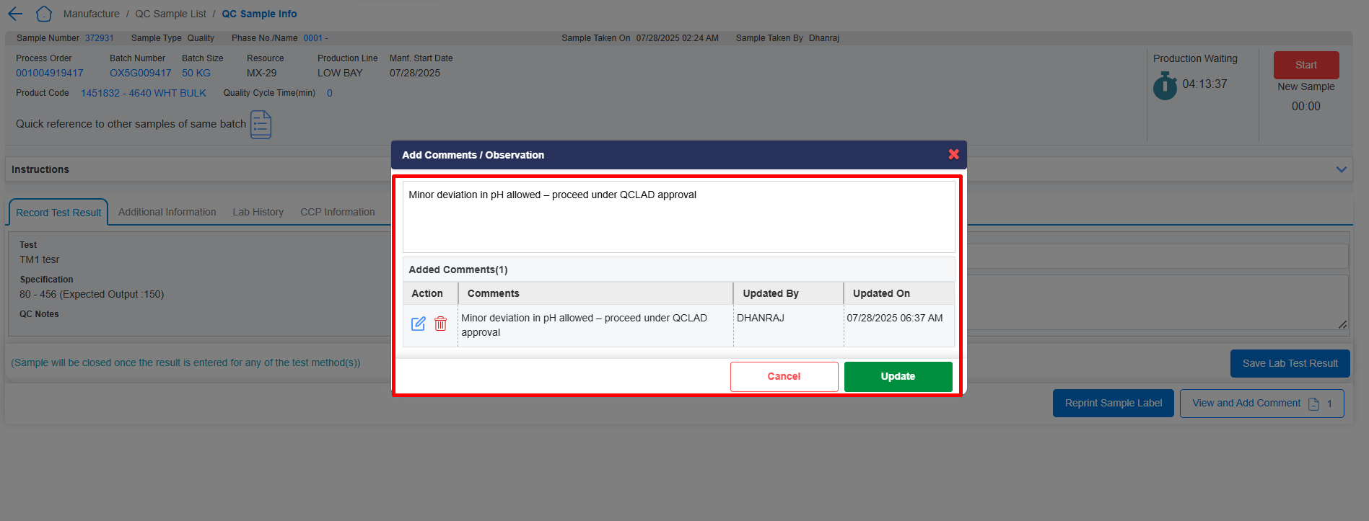

3. 🔄 Move to Next Phase
- MES proceeds with the next phase of the process automatically.
- If this is the last phase, MES will:
  - Mark the process order as 'Manufacture Completed'
  - Allow the filling phase to begin.

4. 👤 No Operator Intervention
- The concession decision is made by QCLAD.
- No manual action or confirmation needed from MES operators.

🧭 Summary of Case 4 Flow
Step | Description
🔬 QCLAD | Performs test → Result is Rejected, but concession is granted
📤 API | Sends: "sampleStatus": "Rejected", "consesssionRelease": true
📥 MES | Flags sample as Pass with Concession
📝 MES | Shows remark from QCLAD
🔁 MES | Moves to next phase / marks Manufacture Completed if last phase
👤 Operator | No manual input required

Case 5: Reject with QC Resample Required

📤 QCLAD Testing Outcome
- QCLAD rejects the IPQC sample after testing.
- However, instead of allowing it with concession or performing adjustments, they determine that another sample must be tested.
- This triggers a QC resample request.
- In the API, QCLAD sends:
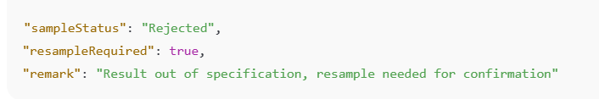
🛠️ MES Action
1. 📝 Logs Rejection Result
- MES receives the result and marks the sample as Resample in the Quality tab.
- The remark from QCLAD is shown in the MES.
  - Example: “High turbidity – please retest”
2. 🔁 Triggers QC Resample Flow
- Since "resampleRequired": true, MES automatically:
  - Initiates the QC resample workflow.
  - Schedules the same phase to be run again but flagged as a resample.
  - A new sample label is generated for the same phase.
3. 🧪 Production/QC Resamples
- Operators will:
  - Take a new sample.
  - Hand over the new label to QCLAD again for retesting.
- The cycle continues until an Approved result is received from QCLAD.
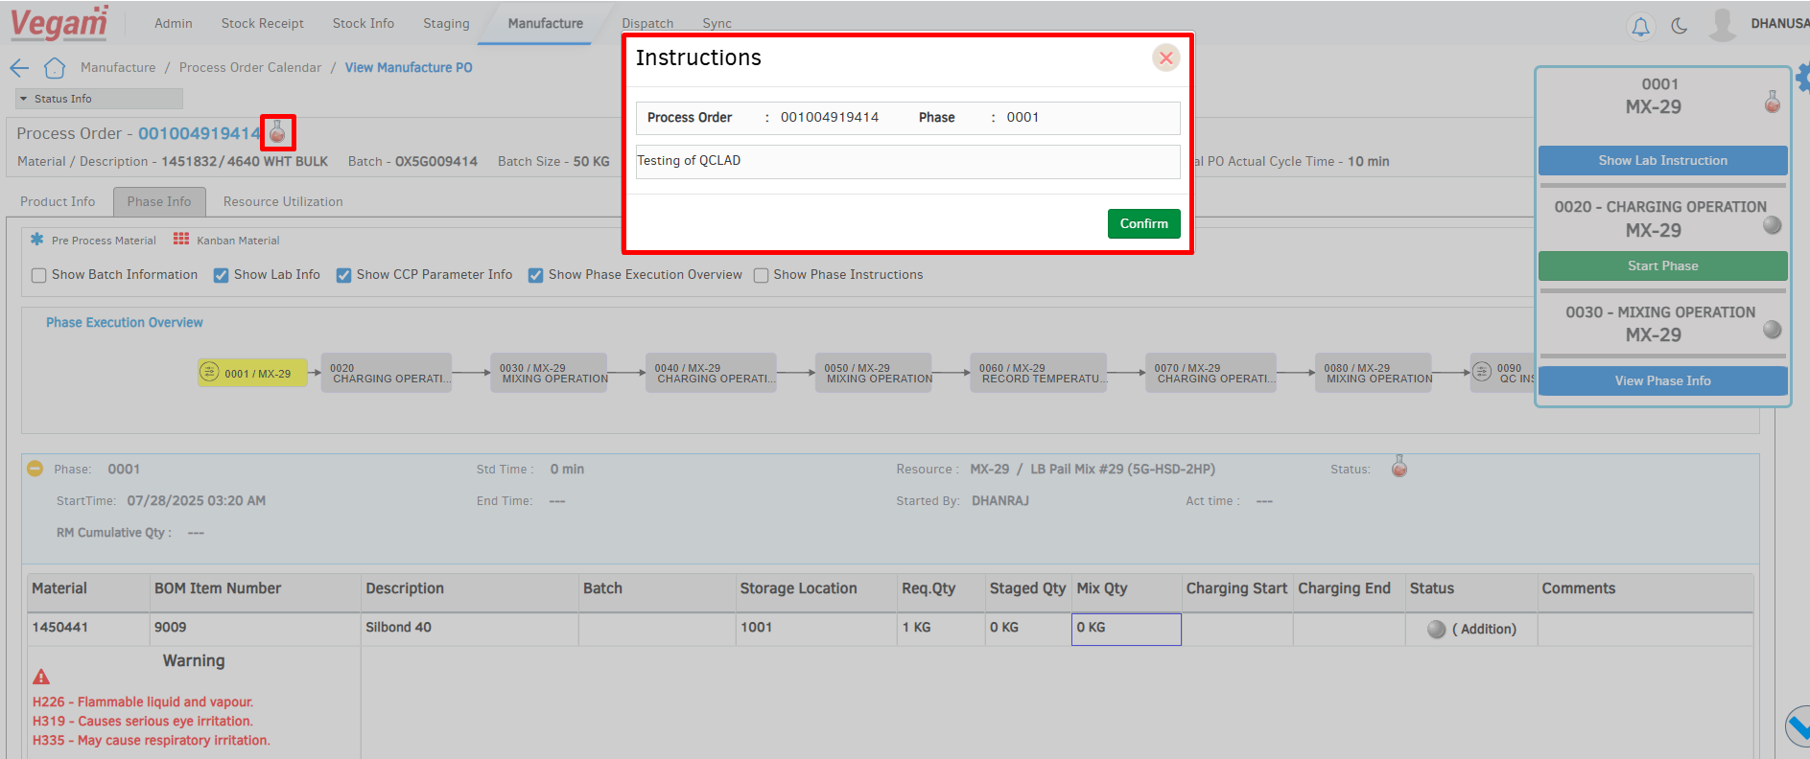
🧭 Summary of Case 5 Flow
Step | Description
🔬 QCLAD | Performs test → Rejects sample, requests resample
📤 API | Sends "sampleStatus": "Rejected", "resampleRequired": true
📥 MES | Marks original sample as Rejected and logs remark
🔁 MES | Triggers resample process and generate new sample label
👤 Operator | Takes new sample and restarts QCLAD testing cycle

🧾 Example API Snippet
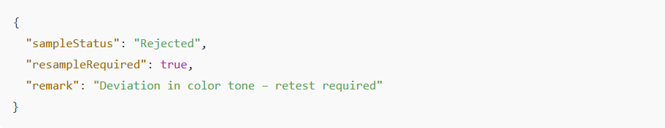

Case 6: Final Rejection – No Further Processing

📤 QCLAD Testing Outcome
- QCLAD conducts the test and completely rejects the IPQC sample.
- There is no adjustment, no resample, and no concession.
- It is considered a final rejection.

🛠️ MES Action
1. ❌ Mark Sample as Rejected
- MES logs the result and updates the sample status as Rejected.
- The rejection reason or remark sent by QCLAD is shown in the quality module.
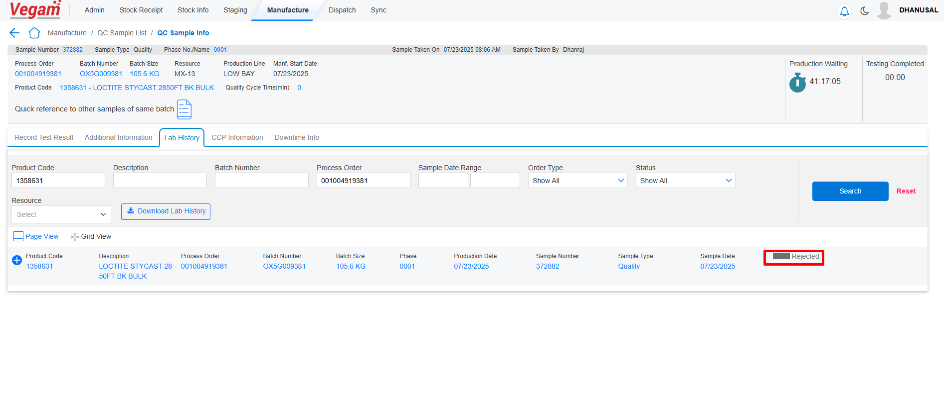

2. 🚫 Stop Further Processing
- Since the sample is fully rejected:
  - MES does not allow any further production activities for the affected order.
  - No start of next phase, no filling.
3. 📦 Mark Order as Rejected
- The corresponding Process Order is flagged as Rejected.
- This serves as a hard stop for the order and is visible across MES modules.

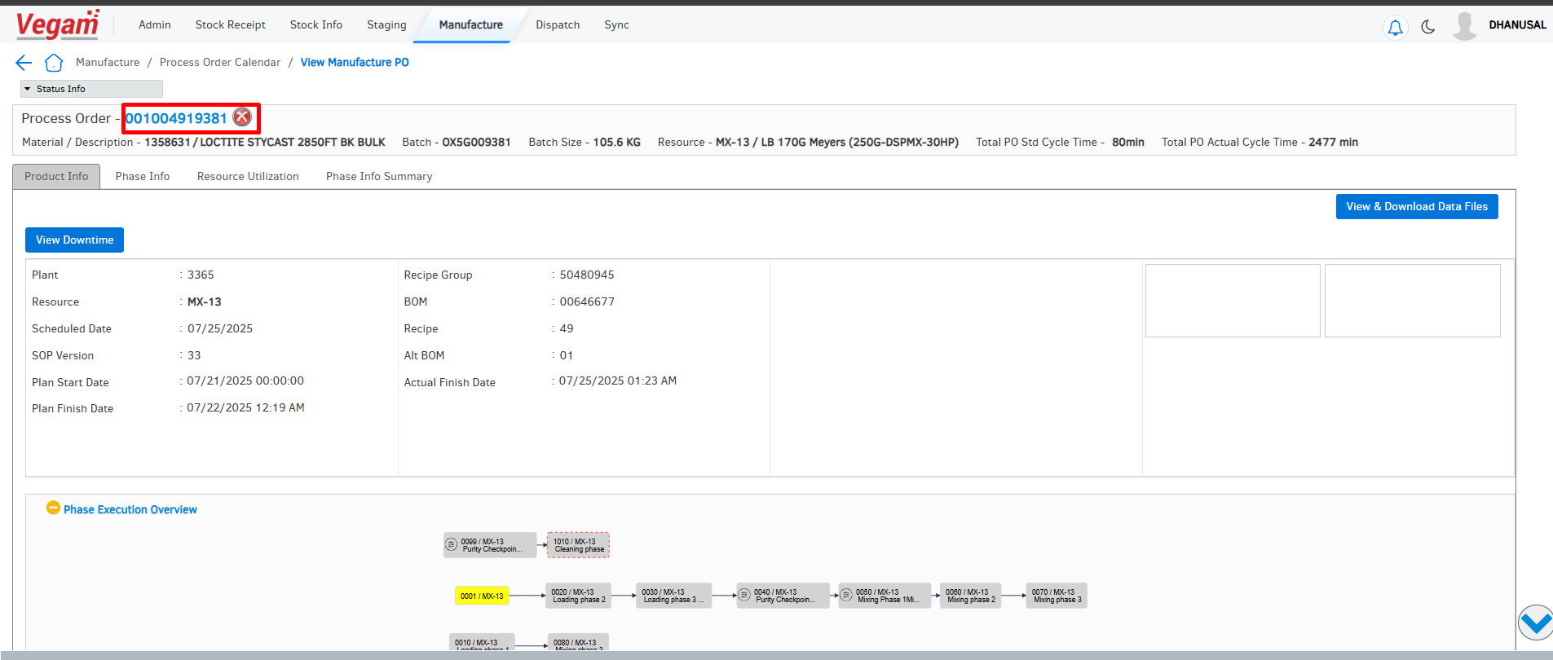

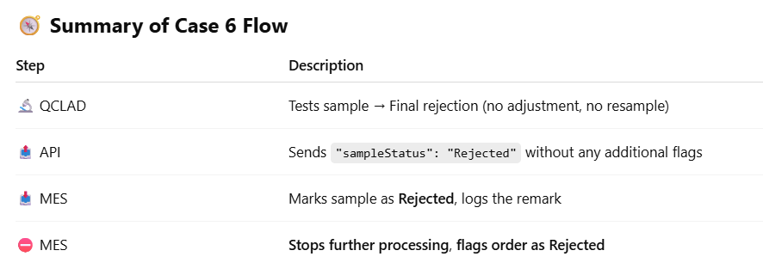

🔒 Example Scenario
Let’s say the sample failed a critical quality parameter (e.g., contamination or wrong material used). QCLAD deems it unfit for use and sends:
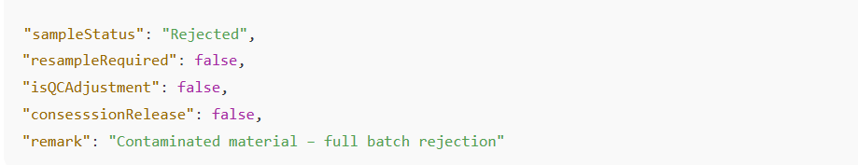

Sample Status Update – “Testing in Progress” in MES
When a sample is sent to QCLAD, MES shows the status as “Awaiting Result from QCLAD”. However, users need visibility when QCLAD has received the sample and has started testing it. Hence, QCLAD will send a status update to MES, indicating:
- The sample is currently under testing
- The estimated time for completion of testing

MES will use this information to update UI/status accordingly and control the timing of QC decision actions.

🔄 Proposed System Behaviour
🔹 Step 1: QCLAD Sends Sample Status Update to MES
QCLAD will push a JSON payload to MES which includes:
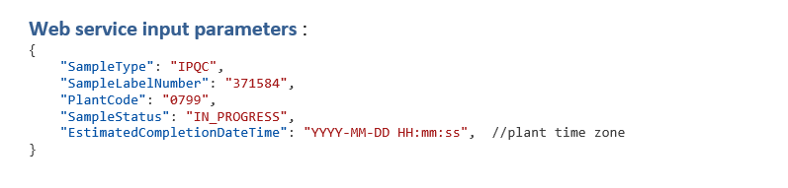
🔹 Step 2: MES Updates Status
- MES updates the sample status from "Awaiting Result from QCLAD" to "Testing In Progress from QCLAD"
- This status is displayed in the SFS Quality Module, allowing operators and QA to know testing is underway.
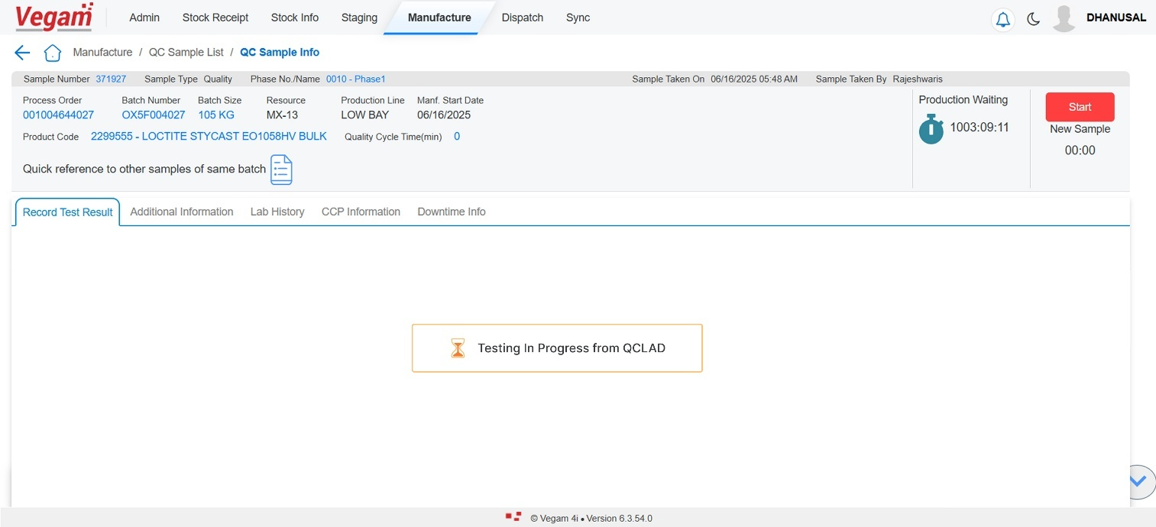

🔹 Step 3: Timer-Based Action Control
- MES will not allow any QC decision buttons (like QC Pass, Reject Batch, Adjust Phase, Issue Addition, QC Resample) until the estimated time of completion has passed.
- During this period, MES waits ensuring no premature action is taken.

🔹 Step 4: Enable QC Decision Buttons
- Once the estimated completion time elapses, MES will:
- Unlock the QC decision buttons
- A comment box will appear for operators to manually enter remarks, and:
- ✅ Entering a comment is mandatory before any QC action (Pass, Reject, etc.) is taken.

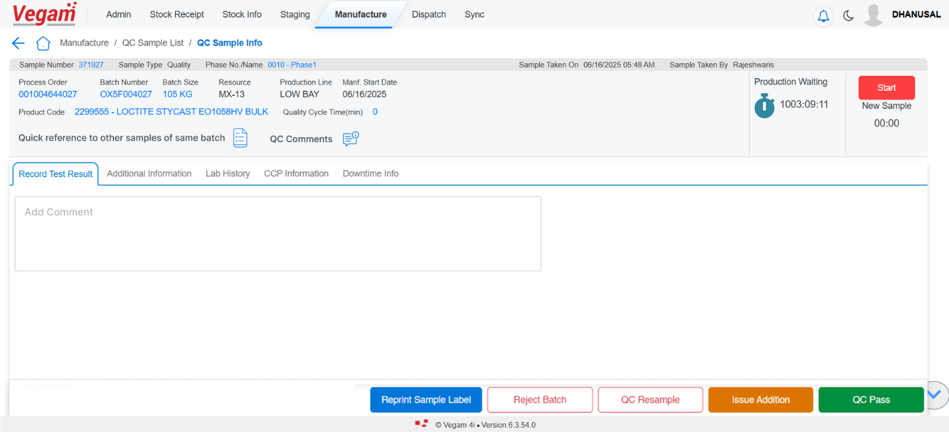
Error Handling – QCLAD Result Posting Failure
When QCLAD sends QC test results to MES via API, there may be cases where:
- The API payload is invalid
- Estimated Completion time is passed
- The Log the failure clearly
- Display remark in the quality module
- Provide manual QC decision options to the operator
- Enforce mandatory comment entry before allowing any decision

🔄 Proposed System Behaviour
🔹 Step 1: QCLAD Sends Invalid or Failed Result Payload
Example failure scenarios:
- Estimated Completion time is passed
- API processing error

🔹 Step 2: MES Detects Failure and Logs It
- MES will mark the sample as:
  - “Error in Receiving Results from QCLAD”
- An error remark is shown in the View and add comment of Quality Module (e.g., “Result could not be processed. Please review manually.”)
- Error details are logged internally for audit and debugging
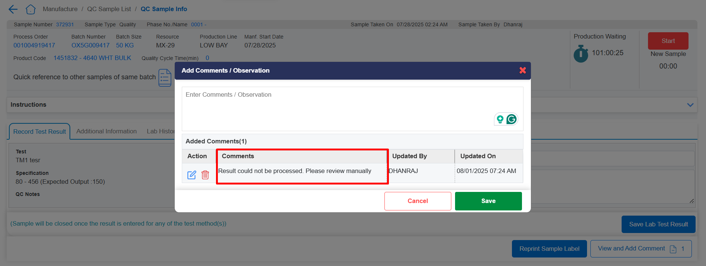

🔹 Step 4: Enable QC Decision Buttons + Mandatory Comment
- MES enables decision buttons like:
  - ✅ QC Pass
  - ❌ Reject Batch
  - 🔁 QC Resample
  - ⚙️ Adjust Phase / Issue Addition

- A comment box appears along with these buttons.
  - Entering a comment is mandatory
  - User cannot proceed without entering a justification/explanation


Introduction of Activity Number in SOP Flow (Non DCS Flow)
Smart Factory System will be enhanced to capture and print the Activity Number during the IPQC process by allowing users to define it directly in the Manage SOP page.

🧩 Current State
Currently, when an IPQC sample is generated, the system prints a label containing:
- Material details
- Batch number
- Sample number
🔄 Proposed Enhancement
🔹 Manage SOP Page Update
- A new text box labelled "Activity Number" will be added on the Manage SOP configuration screen.
- The user can enter the Activity Number specific to each phase.
- This field will be optional but recommended, and will allow numeric entries.

🔹 IPQC Label Update
- When an IPQC sample is generated from the SOP:
  - The entered Activity Number will be fetched from the SOP configuration.
  - This Activity Number will be printed clearly on the sample label sent to QCLAD.

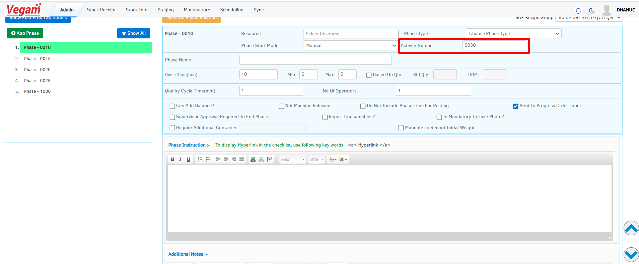

Note - The SOP Excel template will be updated with a new column for Activity Number.

Comments box:

Sl. No | All CRs | Efforts in Man days | Priority
1 | CR Vegam and QCLAD Integration |  | High

Additional Information

Technical Assumptions and Dependencies
State assumptions/dependencies related to any of the CRs; otherwise, state NA
# | Assumption/Dependency | Impact
 | None/ NA

Technical Risks and Issues
State risks/issues with mitigation (avoiding the risk) OR contingency (plan B to come out of the risk) related to any of the CRs; otherwise, state NA
# | Risk | Impact | Mitigation / Contingency
 | None/NA

